

Finance and Sustainability Plan

Use of The Prestonpans Town Hall to create a foundation for future growth

The Battle of Prestonpans (1745) Heritage Trust

August 2021 v3





Contents

1. About The Organisation 3

2. The Purpose of the Work 3

3. Visitor Demand 3

4. Income Generating Products and Services 12

5. Funding Plan 15

6. Financial Plan 16

1. About The Organisation

The Battle of Prestonpans was the first battle of the last Jacobite Rising. It took place on 20-21 September 1745. The Jacobite army led by Charles Edward Stuart (Bonnie Prince Charlie) achieved a stunning and unexpectedly one-sided victory over the Government forces led by Sir John Cope.

The Battle of Prestonpans (1745) Heritage Trust is a registered Scottish charity committed to understanding and interpreting the battle and its legacy, and protecting the battlefield site.

The organisation is a company limited by guarantee (SC 302280) & with charitable status (Scottish Charity 037447)

2. The Purpose of the Work

The Trust has two funding challenges from the end of 2021

1. To fully fund a circa £10m[1] visitor attraction in East Lothian
2. To fund the Interim period from now till the new museum site is built in 2027.

Using the Town Hall in the interim period is a time of market testing. This short report will help to plan the work over the next 5 years, creating targets for services and finances that will be full sustainable, helping to hone ideas so that they are embedded and well advanced when the full experience is operational.

3. Visitor Demand

**Market Segments**

The interim heritage centre at the Town Hall will need to build significant demand to ensure it is sustainable. This is split into two market segments;

1. Local people who will be committed to the concept and who will be repeat visitors.
2. Visitors from further afield who will attend once, or very infrequently

**The Visitor Market**

The following indicates the direction of travel for tourism nationally, in relation to covid, regionally and with reference to heritage;

*Tourism and hospitality trends*

This section is intended to provide information on the industry, including key market segments and trends, and will inform any future marketing strategy for the Prestonpans Town Hall and its access to wider Lothians, Scotland and beyond.

Visit Scotland have identified four key trends in tourism across Scotland[2].

|  |  |
| --- | --- |
| General trends: | Implications for The Prestonpans Town Hall: |
| **Offer more genuine experiences and help visitors to be more than ‘tourists’.** Recommendations include to be overt in marketing about organisational values; encourage visitors to explore smaller communities. There is a reference to looking “beyond the boutique hotel”, and to consider restored or repurposed accommodation where visitors would love to spend time. | Developing strong community links via The Trust and partners at the Prestonpans Town Hall is likely to appeal to visitors.  Linking visitors back into the community rather than just the battle site, encourages contact local businesses and the local shop which will bring visitors into contact with the local community  Strong links from Jacobite heritage other element such as coalfield heritage shows visitors links to local industry |
| **Limitless discoveries**: marketing the whole of Scotland, and joining up itineraries. This includes look at ways to create more joined up experiences, potentially connected by geography or theme (such as heritage). Businesses need to collaborate around new attractions and routes to help join up the gaps in the overall visitor experience. | The Prestonpans Town Hall offering can be linked up with other visitor attractions in the Lothians from the North Berwick Bird Centre, Tantallon Castle, Glenkinchie Distillery, Battlefields at Dunbar and Pinkie Cleugh, the national Jacobite Trail being hosted by the Trust the Museum of Flight and many others.  . |
| **Evolving traveller** recognising the many different types of visitors, both culturally and demographically. Visitors increasingly want to have a ‘real’ experience and will want to live more like a local to find it. | **Give visitors the chance to meet people and ‘live like a local’.** Visitors (particularly international) want to go home with a unique story to tell – often, this comes from a chance conversation which can take place in the shop or the village centre.  Potential partnerships with local and regional groups will make the destination more than just a one day stop off. |
| **Technology to stimulate and inform** using widely available technology and data capture to improve and influence the visitor experience. Find out more about the umbrella platforms visitors use and make sure your organisation is much more visible. | It is **essential for the Battle of Prestonpans experience to be in the digital space**. Make it easier for people to find the site and to book seamlessly.  The concept already has apps built in and is comfortable in the digital space. Webinars are planned for the next 5 years. |

**The visitor market[3]**

Some key figures for Scotland pre pandemic

* 2019 was the best year for overnight tourism in Scotland with demand up by a sixth.
* 80% of these trips were by UK based visitors
* Expenditure rose by 6%
* Tourism businesses were up 3% and employment rose by 5%

**Overview of tourism in Scotland**

**Key numbers**

Tourism in Scotland represents billions of pounds of income each year. It is estimated that in 2019, 16 million domestic and international visitors in Scotland spent a total of £5.5 billion. The tourism industry has been consistently growing over the last decade until the Covid-19 pandemic, with an annual average growth rate of about 2% trips per year and 4% expenditure[4].

**Reasons to visit Scotland**

According to the large Scotland Visitor Survey, the scenery and landscape are the main reason why people decide to visit Scotland (50%). Multiple elements relevant to Prestonpans project are also among the highest ranks reasons, including history and culture (33%), closeness to home (15%), the range of activities available (14%), wanting to visit a particular attraction (9%) and an interest in their Scottish ancestry (9%) that may be linked to a wider interest for Scottish history[5].

History and culture are one of the three key drivers for both first time and repeat visitors. First time visitors are especially interested in scenery and landscape (58%), history and culture (47%) and going to a place they have always wanted to visit (42%). Repeat visitors decide to go to Scotland because of its scenery and landscape (47%), because they have holidayed before and wanted to return (32%), and because of history and culture (29%)[6].

**Planning and advertising**

Over a third of Scottish tourists (35%) planned their overnight trip within Scotland less than a month in advance, while international tourists tend to plan further ahead.

The main resources used to plan overnight travels to Scotland and decide what activities to do are website (69%) and talking with friends and family (58%). However, printed travel guidebooks and printed brochures remain a significant source of information (17% and 13%, respectively)[7].

**Domestic tourism in Scotland**

Understanding domestic tourists’ interests and habits is especially relevant considering the impact of Covid-19 pandemic and subsequent restrictions on international travel.

**Key numbers**

Domestic visitors travel overnight much more than international tourists. In addition, the total expenditure for domestic travel has been consistently over 20% higher than expenditure of international travellers. While domestic travellers spend have a lower average expenditure per trip, they are a significant market[8].

**Domestic and International Overnight Trips in Scotland, 2009-2019**

**Scottish tourists’ drivers**

* The three main drivers for Scottish visitors are the scenery and landscape (44%), closeness to home (36%), and to get away from it all (29%).
* In addition, 26% mentioned they have holidayed there before and want to return to the same place and 25% mention the easiness of access
* Deals and special offers (12%) and accommodation prices (8%) are also cited as important drivers for Scottish people’s decision to visit Scotland rather than go abroad[9].

**Heritage Tourism**

In 2018, over 5.2 million people visited staffed Scottish heritage attractions, which represents a 5% increase from the previous year. This reflected an increase in both Scottish and international visitors in heritage attractions. They generated £620 million local tourism expenditure[10].

70% of Scottish heritage sites reported a loss of revenue caused by the Covid-19 pandemic in early 2020[11].

Activities targeting young people can offer heritage sites a significant increase in visitors and income. For example, Aberdour Castle saw a 42% increase in visitors compared to the previous year when they took part in a large LEGO exhibition in 2018[12].

**Visitor Patterns in the Lothians**

**Tourism in Edinburgh and Lothians**

**Overview**

Edinburgh and Lothians is the most popular travel destination in Scotland, with 5.3 million overnight visitors and 24.7 million day visitors in 2019. In 2019, overnight tourists spent an average of £1.98 billion in the region and day tourists spent an average of £1.30 billion[13].

**Domestic and International Overnight Tourism in Edinburgh and Lothians, 2013-2019[14]**

* Edinburgh and Lothians received more overnight trips from British travellers (3.05 million) than from international travellers (2.28 million) in 2019.
* British travellers spend less during their trips overall (£731 million) than international travellers (£1,249 million).
* This gap may further increase in the future, as it appears that the total spend of international visitors has been consistently increasing over the past years, while spend from domestic travellers remains relatively stable over the years despite an increase in the total number of trips.
* Domestic visitors travelling more but spending less per trip is consistent with national trends.

**Edinburgh and Lothians**

* Edinburgh is the most popular destination in Scotland, as 43% of all tourists who travel to and within Scotland have been there. 26% to Glasgow city, and only 9% have been to Lothians as part of their trip[15].
* While Edinburgh is much more popular for international and overnights trips, Lothians remain a popular destination for domestic day visits. Lothians had an average of 8.2 million domestic day between 2017 and 2019, compared to 19.7 million in Edinburgh.
* In addition, Lothians have seen a 7% growth in spend by domestic day visitors between 2016 and 2018, which is higher than both the national and regional average.[16]

Visitors to Lothians spend 5 days there on average. The three main reasons to visit Lothians are the scenery and landscape (60%), the history and culture (53%) and visiting family and friends (38%). The main activities of people who visit the Lothians are sightseeing by car, coach or on foot (75%), visiting a historic house or castle (73%) and visiting cities[17].

**Domestic travellers in Edinburgh and Lothians**

In 2019, British residents made 3.1 million overnight trips to Edinburgh and Lothians, spending 7.9 million nights and £731 million[18].

* 74% of overnight domestic travellers stayed in Edinburgh and Lothians between 1 and 3 nights, 22% stayed between 4 and 7 nights, and only 4% stayed over 8 nights.
* 50% of overnight domestic travellers stayed in Edinburgh and Lothians for holidays, while 32% stayed for VFR and 15% for business purposes.
* It is an equally popular destination among all age group, with each age group from 16-24 to 65+ representing between 11% and 20% of visitors.
* It is a popular destination for domestic travellers all year-round. The summer is the most popular, with 31% of visitors coming between July and September. However, all periods are popular, as the least popular (January to March) still welcomes 21% of travellers to the region.

**Developing tourism in Prestonpans**

Around 1.7 million people live within a one-hour drive from Prestonpans. (**ONS 2019 – midyear estimates**). 70% of these households have access to a car and could therefore easily access Prestonpans (**2011 census**).

In addition, history and culture are the first motivation of travellers to Edinburgh, with 65% of people mentioning it is the reason they are travelling there. In addition, the majority of the most visited attractions in Edinburgh and Lothians are related to history and culture. Encouraging the tourists who are already travelling to Edinburgh for history to drive less than an hour to go to Prestonpans could open a significant market[19].

Most visitors in Scotland use their own car (49%) and walk (33%) during their trip. A significant portion also use public transport, with public bus and coach (28%) and train (24%) being the most popular.

(https://www.visitscotland.org/binaries/content/assets/dot-org/pdf/research-papers/scotland-visitor-survey-2015-16-full.pdf)

Prestonpans in easily accessible by car, train and bus from Edinburgh in less 45 minutes. As a result, the high population of over 480,000 and high tourism in Edinburgh can represent a significant opportunity for growth in tourism in Prestonpans.

**Various Insight Papers Commissioned by Visit Scotland**

Understanding developing consumer trends is increasingly important during the recovery of tourism following the Coronavirus (COVID-19) pandemic. Visit Scotland’s various Innovation Insight papers evolving trends and consumer expectations. The various papers[20] focus on the positivity around the following themes.

1. Localism and authentic experiences
2. Adaptable adventure
3. Workcations
4. Artisanal retail and food and drink
5. Voluntourism
6. Wellness

**Impacts of Covid-19**

* Covid-19 and subsequent restrictions have had a significant impact on the tourism industry in Scotland.
* International tourism was significantly impacted and faced a significant decrease, while domestic tourism was less affected. However, domestic tourists are often more price-sensitive and tend to have lower spending patterns than international visitors, which caused a significant reduction in income for most tourism businesses.
* 78% of Scottish businesses said they had a lower turnover in 2020 than in 2019, including 82% of tourist activities, attractions and tours. Cities were the most affected, with 96% of tourism-related businesses reporting a reduction in turnover in 2020, compared to 73% in rural areas[21].
* At the moment, it is unclear what future trends will be, as traditional forecasting methods have proven to be unreliable to evaluate future tourism trends during the pandemic[22].

**Covid-19 and Tourism[23]**

The tourism and hospitality industries have been dramatically impacted in 2020 by COVID-19. Visit Scotland outlined some key tourism trends between Sep-Dec 2020 and looking forward into 2021.

2020 Trips:

* City or large town’ and ‘countryside or village’ were the two most popular types of destination for an overnight stay taken between September- November.[24]
* Hotel/motel/inn remained the most popular choice for an overnight Scotland trip.

Tourism projections:

* *Convenience, Reassurance, Value, Inspiration* and *Connection* have all been identified as key consumer drivers in the era of COVID-19. Innovative and agile providers are seen as the catalysts for recovery in tourism through adaptation and flexibility.
* Despite the vaccine roll out, it is possible that there may be future waves of infections. Indeed, the return to 2019 levels is not predicted to be seen until 2023.
* Domestic travel is recovering fastest. Notably, accommodation occupancy rates in major European city destinations are growing slower as opposed to rates in the countryside and natural areas.
* The desire to travel remains among consumers.
* South West of England and Scotland were consistently the most popular destinations throughout the study for intended trips and actual trips reflecting the availability of rural and coastal locations available to travellers
* Younger demographics without underlying health conditions and families are more noticeable in domestic breaks at present. This opens opportunities for price-conscious packages for younger domestic consumers embarking on their first staycations. Finally product offering, specifically the presentation of a providers values and attitudes will become increasingly important. For Scotland there is now an opportunity to become a highly desirable and sustainable destination.
* Small group travel and private tours, personalisation and bespoke products and planned and curated travel will develop through consumer demand and practicalities of adherence to legislation.
* Tourism is likely to flow towards less crowded destinations. Hospitality is becoming a priority. The result will focus a shift from footfall and number of visitors towards prioritising spend per visitor. Which provides an opportunity for the tourism sector to focus on improving the quality of experience versus the quantity of tourists.

**VisitScotland on behalf of the Scottish Tourism Emergency Response Group (STERG) Covid Impact Tourism Industry Survey – Wave 3 January 2021**

This was a Scotland wide tourism sector survey with a final sample of 2,974 responses. The following are the key findings;

* Over a third of businesses overall reported that they did worse than expected when they re-opened in summer/early autumn, although a significant proportion (25%) did do better.
* Regardless of whether businesses felt they did better or worse than expected when they re-opened, most (4 out of 5) reported that their turnover was lower than in a normal year.
* Amongst accommodation providers who opened in the summer and autumn months the average occupancy peaked in August at 64%. However, occupancy levels were well below 2019 when they were at least at 80% for July, August and September.
* Accommodation providers in cities experienced the lowest occupancy rates, while rural providers had the highest – likely to reflect the desire amongst visitors to holiday in areas away from crowds.
* The value of revenue lost was highest for hotels, B&Bs and guesthouses

**The latest Visit Scotland report (31 May to 2 July 2021)**

Intentions to take an overnight UK trip in either the summer or autumn remain at the same level as in the previous reporting period – there are still a considerable proportion of the UK population for whom UK breaks and holidays are not yet a consideration. This plateauing of sentiment is likely driven by increasing COVID-19 case numbers – ‘catching coronavirus’ is the second biggest driver of low travel confidence (after the threat of government restrictions).

The previous report suggested that Scotland residents were some way behind UK residents in their comfort levels with everyday activities and travel confidence. This large gap was attributed to differences in restrictions (at the time, parts of Scotland were in level 3, whilst England was in the equivalent of level 2). Although, this gap has now closed significantly, Scotland residents are still slightly more cautious.

44% of UK adults anticipate taking an overnight trip between July-December 2021, with over a third (34%) planning to do so this summer (July – September).

After the South West of England (22%), Scotland is the second preferred destination choice for UK intenders this summer (13%) and third for the autumn (October-December). For Scotland residents, 60% intend to take a summer break in Scotland (an increase on previous reporting).

Over half (55%) of Scotland summer intenders have already planned their Scotland trip with 42% having booked it, a significant increase on the proportion that had done so in late May.

The Highlands remains the most favoured destination for Scotland summer intenders living within and outside Scotland.

4. Income Generating Products and Services

**Suite of Events**

This includes re-enactments and other events related to Jacobite heritage.

Our own established Alan Breck Regiment of Prestonpans Volunteers established 2007 has some 40 members. A full scale weekend re-enactment attracts as many as 300 international volunteers and 4,000 visitors.

Re-enactments are currently charged at £6 but the proposal is to drop this to £5 which will firstly make the administration of this easier as there will be less need for fiddly change. In addition, this may attract more attendees. 240 tickets were sold on online for the recent re-enactment with more bought face to face.

Gaelic is a strong part of the identity of the Centre so there may be opportunities for things like Gaelic concerts and other cultural events.

**Merchandise**

There is a growing range of items for sale, from tea towels to a bespoke CD put together by Greentrax.

Books are a good seller but due to the low print runs the profit margins are relatively small. Production and warehousing tend to take the bulk of the surplus.

There are also smaller items such as key rings, tea towels, canvas bags and so on.

**Permanent Exhibitions**

The most important elements perhaps are the two internationally renowned tapestries in exhibition. They have been seen since 2010 by over 1 million visitors and there is every confidence they have a strong ongoing market if they are imaginatively presented with in depth interpretation.

Secondary exhibitions are also a vital element in ensuring repeat visits from the local community as well as a continuous programme of events.

The museum with these permanent exhibitions will be open every weekend for 45 weeks. The vital issue in relation to sustainability is to ensure repeat visits. If people are committed to the pre-development museum, they will visit multiple times. The driver for this will be showing different panels from the tapestries each weekend to attract people more than once.

The package is not a museum, but the seeing the artefacts plus the amazing unique tapestries.

The aspiration is to charge for entry. In Scotland with free entry to mainstream museums, there is a culture of free entry. As a result there is a need for a clear comms plan to promote the need for charging and the independent nature of this heritage centre.

There were 150 people in the opening weekend and this is indicative of potential numbers if the offering is fresh and the marketing strong.

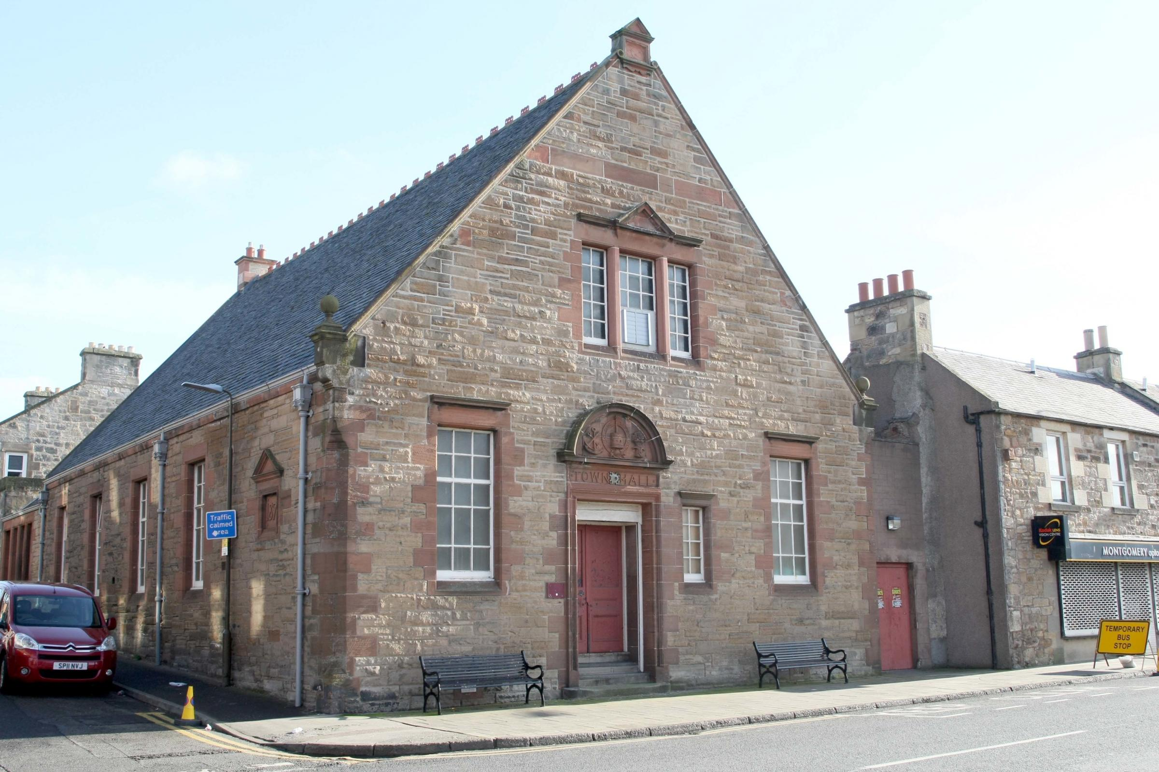As well as the tapestries, there are some artefacts and the museum/heritage centre (as it grows in reputation) will start to accept and exhibit a range of Jacobite related artefacts. Many of these are currently at the John Gray Centre in Haddington.

There are 70 centres around the country which hold items and, in time, these could be gathered in this place which would become known as the Jacobite Heritage Centre.

**Meeting room Let**

Meeting room facilities can occasionally be let but very importantly they can ensure strong engagement with the local community and mutual support/ cross marketing amongst fellow heritage groups.

**Low Level Catering**

Though some visits will be offered low level catering such as tea coffee and simple refreshments, this will initially be offered by donation. Though catering will be a significant part of the full Museum complex when it is constructed, catering is led by the Goth at the moment and there is no desire to compete with that.

**Donations**

Donations will be encouraged in donation boxes but also using QR codes and with opportunities via the website.

**Webinars and learning**

A series of on- and off-line webinars and training courses will be developed that premium members can access for a fee.

The Trust operated with annual audiences of typically 25,000+ with visitors to tapestries depending on venues exceeding a further 50,000. All that has had to stop.

Contact will be made with education providers and local authorities with links to schools. Some schools have visited in the past and this could be a core part of the local Curriculum for Excellence. Though schools struggle with budgets there may be contractual opportunities of funding from things like the Pupil Equity Fund.

**Lending the tapestry**

The tapestries can be lent out to other museums and accredited spaces. For example Dundee recently borrowed it for £1500, though the cost of transport meant that there was limited profit. However, the showing of the tapestry drove sale of books and merchandise to around £4000.

Sections from the tapestry can be lent while some panels remain at the main exhibition in Prestonpans.

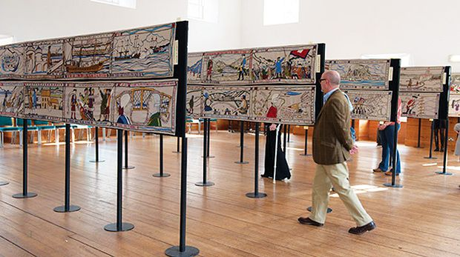**The Tapestries as Drivers**

The Prestonpans Battle Tapestry is an astonishing 103 metres long and an interesting item for visitors to see as it rolls out. Segments can change each weekend, so that people will want to say they have seen it all and will come regularly.

The Diaspora tapestry is 152m long. Segments of this are separated by things like nation and religion. Canada has the biggest proportion of the tapestry.

The local artist, Andrew Crummy, is responsible for the tapestries and there may be the possibility of a future tapestry trail which Prestonpans would be a key part of.

**Staffing**

At the moment all staff are contract staff though there is an aspiration to recruit permanent staff as time goes by.

There is a need for more events management staff and this has been added to the financial model at appendix 1.

**Marketing**

The museum brand will be used to push multiple visits and to change the culture from expecting free entry to understanding the need to charge.

Visitors will be encouraged to buy into a community of active supporters of the vision rather than simply passive attendees at a heritage centre.

The centre is on the John Muir Way so marketing to those walkers as they come through using the heritage centre as a stop off point would be advantageous. 300+ walkers a month come to the Goth for food for example.

**Summary of Financial Position**



5. Funding Plan

The plan over the coming years will require external subsidy and the following are potential funds for interim period, though there may be a cross over with larger capital funds.

|  |  |
| --- | --- |
| Revenue or small Fund | Notes |
| Heritage Lottery Fund | This fund is already active with a submission happening at the moment |
| Garfield Weston | Usually around £50,000  The Foundation supports communities by providing funds towards practical projects such as facilities in church buildings and inclusive activities for the wider community. |
| Mushroom trust | £10,000  Supports art and heritage |
| Barcapel Foundation | £10,000  Interest in Built Heritage |
| Other funding options: | |
| Arts & Business Scotland - Culture & Business Fund Scotland | If a business sponsor is secured, this fund match that funding up to maximum of £40,000. |
| The William Syson Foundation | More related to arts and culture but does mention heritage. Over £5000 |
| The Turtleton Charitable Trust | Maximum £25,000  The majority of grants are made to charities which advance the arts, culture and heritage, particularly heritage and the visual arts. |
| The Stevenston Charitable Trust and other small Trusts | Supports both the Lothians and heritage but only around £3000 |
| Barrack Charitable Trust | Currently supports heritage  Around £5000 |
| Cruden Foundation Ltd | Max £20,000 |
| Russel Trust | Funds heritage - Around £20,000 |
| Loans | Various loan opportunities from Social Investment Scotland, Big Issue Invest and others, normally around 7% interest, though can be unsecured.  With use opening up for weddings, concerts and even green burials, there may be the possibility of servicing loans |
| Community Shares | Potential to raise community shares but there is minimal ability to work towards liquidity so this may be an issue for FCA. |

6. Financial Plan















1. Estimate of £8m for capital and a £2m emdowment.
2. <https://www.visitscotland.org/binaries/content/assets/dot-org/pdf/research-papers/insights-trends-2019.pdf>
3. https://www.visitscotland.org/binaries/content/assets/dot-org/pdf/research-papers/insights-trends-2019.pdf
4. (https://www.visitscotland.org/binaries/content/assets/dot-org/pdf/research-papers-2/insights-trends-2020.pdf
5. https://www.visitscotland.org/binaries/content/assets/dot-org/pdf/research-papers/scotland-visitor-survey-2015-16-full.pdf
6. https://www.visitscotland.org/binaries/content/assets/dot-org/pdf/research-papers/scotland-visitor-survey-2015-16-full.pdf
7. https://www.visitscotland.org/binaries/content/assets/dot-org/pdf/research-papers/scotland-visitor-survey-2015-16-full.pdf
8. https://www.visitscotland.org/binaries/content/assets/dot-org/pdf/research-papers-2/insights-trends-2020.pdf
9. <https://www.visitscotland.org/binaries/content/assets/dot-org/pdf/research-papers/motivations-to-visit-2015-16.pdf>
10. https://www.historicenvironment.scot/about-us/news/another-record-breaking-year-for-scottish-heritage-sites/
11. <https://www.historicenvironment.scot/about-us/news/hes-unveils-latest-covid-impact-results/>
12. https://www.historicenvironment.scot/about-us/news/another-record-breaking-year-for-scottish-heritage-sites/
13. https://www.visitscotland.org/binaries/content/assets/dot-org/pdf/research-papers-2/regional-factsheets/edinburgh-and-lothians-factsheet-2019.pdf
14. https://www.visitscotland.org/binaries/content/assets/dot-org/pdf/research-papers-2/regional-factsheets/edinburgh-and-lothians-factsheet-2019.pdf)
15. https://www.visitscotland.org/binaries/content/assets/dot-org/pdf/research-papers/scotland-visitor-survey-2015-16-full.pdf
16. https://www.visitscotland.org/binaries/content/assets/dot-org/pdf/research-papers-2/regional-factsheets/edinburgh-and-lothians-factsheet-2019.pdf
17. https://www.visitscotland.org/binaries/content/assets/dot-org/pdf/research-papers/motivations-to-visit-2015-16.pdf
18. https://www.visitscotland.org/binaries/content/assets/dot-org/pdf/research-papers-2/regional-factsheets/edinburgh-and-lothians-factsheet-2019.pdf
19. https://www.visitscotland.org/binaries/content/assets/dot-org/pdf/research-papers-2/regional-factsheets/edinburgh-and-lothians-factsheet-2019.pdf
20. https://www.visitscotland.org/research-insights/trends/trends-for-tomorrow#inno
21. https://www.visitscotland.org/binaries/content/assets/dot-org/pdf/research-papers/coronavirus-insights/sterg-industry-survey/final-report-27.1.21.pdf
22. https://digitalpublications.parliament.scot/ResearchBriefings/Report/2021/3/8/2700b49a-ae5d-4973-a149-88b7b5144d70#f3da76dc-6801-4c3b-a248-f833969d0d53.dita
23. Visit Scotland Post COVID19 Tourism Consumer Trends
24. visitscotland.org/binaries/content/assets/dot-org/pdf/research-papers/food-and-drink-extract-svs-2016.pdf