Battle of Prestonpans Jacobite Heritage Museum
Interpretation, Education and Events Plan

Introduction
The Battle of Prestonpans (1745) Heritage Trust have agree a five-year lease on Prestonpans Town Hall, refurbishing the Victorian building and converting it for use a museum and heritage space. For the first time, this will provide a dedicated facility for the Trust’s education, events and exhibitions programmes, and a place for visitors to discover the story of the famous Jacobite victory here in 1745.
Prestonpans Town Hall opened in 1897, and where possible the Trust is uncovering and preserving the original features of the building. Following the Trust’s refurbishments, the building will contain the following facilities: main exhibition hall; meeting room; reception (including small shop); kitchen/staff room; and toilets. There is a ramped entrance and a wheelchair lift for the upper lobby, making all parts of the building accessible.
Within the building, space has been allocated to interpret the history of the Town Hall itself, and for potential small temporary displays from within the community. The main exhibition will be focused on the interpretation of the Battle of Prestonpans and its place in the wider Jacobite story. This will be the most important area of the building, the Jacobite Heritage Museum.
This document presents an outline of the Trust’s ambitions for how this core space will be presented and used. It comprises three parts: Interpretation, Education, and Events

Interpretation
The intention in the main hall is to:
- provide a consistent visitor experience interpreting the Battle of Prestonpans;
- support repeat visits through rotation and change;
- retain sufficient space to facilitate a range of event types.
The hall has limited wall space available for exhibiting interpretation material and a number of constraints and interruptions, including: large window bays on the north and east walls, a large decorative dado on the south (stage) wall; a continuous dado of wooden cladding, which affects possible hanging heights; and intermittent Victorian ventilation boxes. This largely confines the use of the wall space to picture hanging, suiting the large-scale formats of the Trust’s Andrew Hillhouse collection, for example.
As a result, it is necessary to create additional artificial wall space within the hall. It is proposed to do this with a set of hollow wooden partitions, approximately 2m in length and height. The current plan is for 5 such walls.
The first two are arranged in an “L” shape, locking together for stability. On the outside of the L, The ’45 is contextualised as part of a longer conflict and the journey to Prestonpans explained. On the inside, the compositions and equipment of the two armies are compared and contrasted. Into the walls on this side are a number of recessed display boxes in which small finds such as musket and cannon balls are displayed. Secured replica weapons are secured to the walls’ exterior and can be touched by the visitor.
The other three partitions are connected together to form a single wall, locking together and onto the large Battle Board model for stability. On entering the museum, the visitor sees straight across to this wall, fronted by the model of the battlefield landscape, across which the narrative of the battle itself is boldly and vibrantly presented.
The rear side of this wall is dedicated to the Prestonpans Tapestry, the centre-piece of the Trust’s collection. The wall is long enough to hang one 5m section of the Tapestry (there are 21 such sections): the piece displayed will be changed on a regular basis, progressing the story of the campaign. Talks and events can pick up on specific themes or locations referenced in that progression, and the set of accompanying interpretation panels will be changed at each rotation.
Below the Tapestry, hanging from coloured woollen braids, will be 104 tags with the titles of each Tapestry panel on one side and the story of each of the stitchers on the reverse. A QR code will link to the appropriate image on the App. A digital screen, mounted on the east wall filling the lower portion of the central window recess, will play an animated film of the full tapestry.
The Tapestry’s light exposure will be limited to acceptable levels by the regular rotations, the placing of UV filtering film on the lower panels of the east wall windows. Levels will be regularly monitored.

A major part of the exhibition will be a fully refurbished and re-presented model of the battlefield landscape, which will be mounted onto a large plinth (which supports the partition wall behind it). This will be displayed at an appropriate height, with interpretation around the edges to explain the buildings and features. Like the temporary display walls, the model’s plinth will be designed so as to be movable in order to facilitate special events.
It is envisioned that two secure display cases will present higher-value artefacts and objects, and these will be positioned (1) near the north-west corner and (2) at the centre point in front of the stage. The latter will focus on the items relating to the two army commanders, Prince Charles Edward Stuart and Sir John Cope. The former will initially display objects relating to the wider cultural legacy of the battle, and will then be used for special displays of temporary loan items. In addition, there will be a free-standing plinth which will be used to showcase a particular item of interest which, again, would change.
In addition to these elements, there will be a wall space dedicated to the Trust’s piece of the famous Thorntree and the associated story of Colonel Gardiner, using shallow wall-mounted display cabinets beneath the large Andrew Hillhouse painting of Gardiner’s last stand.
A children’s zone will be established in the north-east corner. This area, like all the event zone, will be distinguished from the main area by the change in flooring (indicated green below) and the low wall (enclosed brick) which once formed the lower course of the original vestibule. The later matching low walls on the west side will be removed altogether, and the east side wall will be reduced in size and clad to the appearance of stone dyke. This will service as a barrier delineating the children’s area. The area itself will be dressed as a military camp, with canvas “tent” canopies and a felt campfire. The tents will contain children’s books, activity sheets, and other appropriate resources for learning and play.

The overall layout of the intended core exhibition is indicated in the plan below
(not all elements to scale):

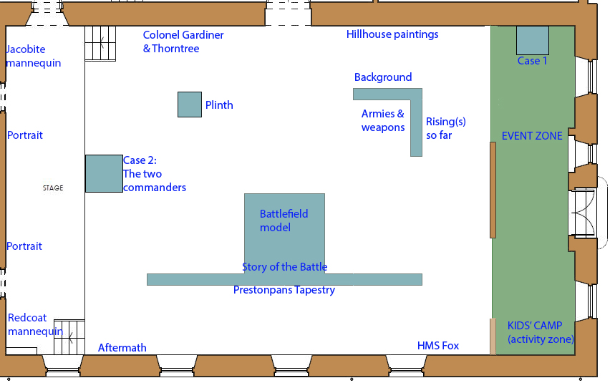

Events
The Trust will aim to run a three-tier event programme to encourage repeat visits, diverse audience engagement, and a sense of continuous activity. The north end of the main hall will be designated as a discrete event space for smaller scale activities such as craft tables or object handling tables. This will be indicated by the different flooring, with the remains of the old porch wall preserved as a low physical partition. This will aid visitor flows whilst allowing event participants to feel they are within the main gallery space.

The museum will run a series of regular repeat events, which occur on several weekends throughout the year. They are provided to the public free of charge during their visit and can be provided with low cost. They should encourage increased visitor donations and repeat visits.
This type of event is expected to include:
Meet the Redcoat/Jacobite costumed interpretation with handling objects
Jacobite themed kids’ craft sessions
Storytelling sessions
Seasonal lecture programme (building on the work begun during lockdown), combining both physical talks with livestreamed events. Recording and livestreaming facilities will be available in the meeting room for smaller or online-only sessions.
In addition, we will respond to audience expectations by providing anchor events with appropriate themes around particular holidays, anniversaries or seasonal events: eg, Burns Night, St Andrew’s Day, the Christmas period, and during school breaks. These events will provide regular anchor points in the programme and encourage visitor loyalty. In 2022, the anchor events will include a session connected to the royal jubilee (coincidentally, the Town Hall was originally opened in a Jubilee year).
The centre-pieces of each year will be the headline events. These will be larger scale events and may require the re-formatting of the main hall, rolling the exhibition walls back to create larger audience area. They will generally be ticketed events, such as musical or theatrical performances, an academic conference, or a wargamers’ day.
We will also host meetings of the local heritage network every three months, and the community council every month. Space within the hall might also be used as a venue during the Three Harbours Arts Festival in the early summer.

Education
The Battle of Prestonpans (1745) Heritage Trust has a strong track record of engaging with local schools, both with visits to the battlefield and with outreach sessions. Until now, the scope of our learning offer has been limited by the lack of facilities such as toilet and lunch spaces, which deters visits from further afield, and the lack of an indoor space to offer an enhanced experienced. Whilst we have sometimes been given permission share use of other venues’ facilities, this is not sustainable long term and raised a number of issues. Following the current pandemic, access to dependable and safe facilities is even more critical, and the opportunities provided by the Trust’s renovation of Prestonpans Town Hall will be able to provide that
Key Considerations
Staff – we currently have two experienced staff members capable of running a learning programme, funded until the end of 2021. In addition to support this staffing further, we would look to recruit and train additional volunteers to help with facilitating larger groups. Any such volunteers would be Disclosure Scotland checked.
Location/Facilities – the lease of Prestonpans Town Hall provides the best platform for kick-starting an updated learning programme, as we have access to both the basic facilities we need and options for expanding the programme to increase engagement and accessibility.
Online Offer – with the move to at-home learning, online resources have become more sought-after and valuable to teachers and pupils. It is expected that the use of online materials will continue even after in-person visits resume, and should be planned into our learning programme. The availability of online resources or Zoom/MS Teams lessons will also be useful as a tool to engage with schools outside a reasonable commuting distance.
Community Engagement – the new museum and heritage space at the Town Hall will provide a powerful interface between the battlefield heritage and the community itself, and a platform for engaging with adults and community groups for learning and skills-development initiatives beyond formal education.
Options
With the Town Hall as the base for our programmes, we are in a much stronger position to increase our engagement with the community, as well as build up a larger client base with regards to schools.
We have the potential to offer a variety of different programmes that suit the needs of the visiting group, both full day and half day, that might include a combination of the following:
- Battlefield tours
- Object handling
- Craft workshops
- War-gaming
- Storytelling
- Music and song sessions (English and Gaelic)
We can also provide the facilities that schools need i.e., lunch/snack spaces, toilet, cloakroom and make sure that we are doing so in a Covid safe way.
Visits could be supplemented with digital content sent to the teacher either before or after the session. This would either provide a grounding for pupils, so they are able to get the most out of their visit, or a follow-up activity to reinforce their learning. The new website is accessible and easy to navigate for both teachers and pupils, so the provision of additional resources should be straightforward and utilised. This would also be useful for schools that are unable to visit due to cost or distance, as well as those who choose an outreach option.
In addition to school visits, options for adult visitors to the Town Hall and/or the battlefield could be considered. There have been several adult tour groups in the past who may have had an enhanced visit if there was the option of a talk/workshop to go alongside a tour.
There could also be potential collaboration projects with local crafting groups, for example, to make a set of knitted characters and a quilt for use in the storytelling sessions.
The sessions outlined for schools could be adapted to suit other community groups, such as youth clubs, scouts, cadets or even local nurseries or parent and toddler groups. The facilities at the Town Hall mean that we can potentially book a bespoke session for any of these groups, with the added possibility of refreshments as part of the package.
Alongside the school and community sessions, we could also potentially offer volunteering opportunities to young people completing a Duke of Edinburgh Award, or work experience placements as part of the My World of Work scheme.
Following a period of detailed design and planning for the offer, a pilot phase is recommended which would facilitate real-world feedback from teachers/group leaders/participants. This will allow us to assess and refine the offer, ensuring both desirability and correlation with the Curriculum for Excellence where appropriate. This will also help us to understand what works in terms of facilities and resources, before moving fully to a fee-charging model which will support the long-term sustainability of the programme.
Draft Example Session Outline (Full)
09:30: Arrival at Hall, initial briefing on bus, toilet stop, handwashing/sanitising
10:00: Travel to battlefield for tour inc. Bankton Doocot
12:30: Return to Hall, lunch, toilet, handwashing/sanitising
13:30: Workshop
14:30: Conclude

Draft Example Session Outline (Mid)
09:30: Arrival at Hall, initial briefing on bus, toilet, handwashing/sanitising
10:00: Workshop
11:00: Snack, toilet, handwashing/sanitising
11:30: Travel to battlefield for short tour (battlefield only)
12:30: Conclude

Draft Example Session Outline (Short)
09:30: Arrival at Hall, initial briefing on bus, toilet stop, handwashing/sanitising
10:00: Travel to battlefield for short tour (battlefield only)
11:00: Return to Hall, Snack, toilet, handwashing/sanitising
11:30: Conclude

Draft Example Session Outline (Short)
09:30: Arrival at Hall, initial briefing on bus, toilet stop, handwashing/sanitising
10:00: Workshop
11:00: Snack, toilet, handwashing/sanitising

11:30: Conclude

