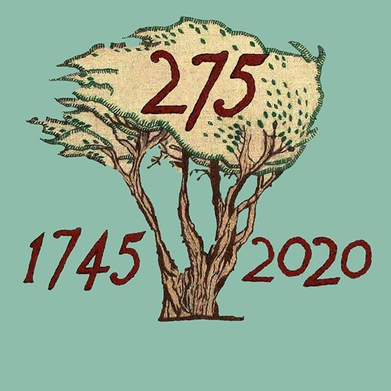

BATTLE OF PRESTONPANS [1745] HERITAGE TRUST
MINUTES OF 114th MEETING OF THE TRUSTEES HELD ELECTRONICALLY FROM JUNE 8th/ 15th 2020 BY EMAIL ITERATIONS & 2xZOOM

QUORATE throughout/ contributing:
Gordon Prestoungrange of Lochnaw [in the Chair]
*Sharon Beck
Gareth Bryn-Jones
Sylvia Burgess
Herbert Coutts
Sharon Dabell
*Arran Johnston
Joe Goldblatt
John Home-Robertson
Avril Wills of Lochnaw
Julian Wills of Dolphinstoun
Mathew Wills of Prestoungrange
APOLOGIES:
Kenneth Cameron
Brett Fletcher
Pat O’Brien

1. MINUTES of 113/20 eMeeting of the Trustees held between 11th/ 18th May 2020 which had been e-circulated by the Secretary, were proposed on ZOOM June 11th 2020 @ 4.05m and unanimously confirmed as a correct written record.

2. JACOBITE TRAIL

01. That Michael Taylor is proceeding to work with an agreed small group from amongst of those who attended the November 2019 Colloquium to agree appropriate next steps including development of a dedicated website; and to arrange a meeting with Jenni Steele re The Outlander Trail at VisitScotland.
02. Resolved: To continue preparation for the discussions with VisitScotland working in partnership with the nationwide sub-group to progress as soon as feasible; Herbert Coutts with Mike Taylor to lead.
03. That the development of the ‘Virtual Jacobite Trail’ as an integral element of the 275th Comprehensive Digital Strategy when deploying NLHF and ‘Restricted Funds’ should be continued with all those attending at the Colloquium on November 5th 2019 included and beyond.
04. That the group in Brittany continues its research and development of their Jacobite Trail there following their discussions at the Colloquium.

3. TASKFORCE 275 REPORTS/ SESSIONAL CONTRACTORS

01. That Facebook activities and reports from the iterative email exchanges of the Taskforce and ZOOM sessions remain creatively positive with great credit due to the commitment of the Sessional Contractors in challenging times.
02. Resolved: That the Revised eAsset Strategy for Project 275 tabled by the Contractors be endorsed and shared with NLHF and VisitScotland including emergent five year resilience scenarios from January 1st 2022.
03. That the PR team led by Martha Bryce will in the coming weeks seek media exposure for the short and longer term benefits of the e-decisions the Trust is taking.
04. Resolved: That the public statement developed by the
Taskforce confirming that a maximum £55/£90K of Restricted
Funds previously allocated as match funding with NLHF and
other donors had necessarily been fully debated and will
continue in support of the Revised eAsset Strategy be adopted
and available for any/ all who wished to understand the Trust’s
decisions. [Policy Paper #14 - June 11th 2020].
05. That unless circumstances change significantly the Trustees will not seek to Pause or Suspend any parts of Project 275 but would explore with NLHF the possibility of an extension beyond December 31st 2021 to make sure the Legacy benefits of the Project are fully captured including the Gaelic dimension.
06. Resolved: That Contractors continue to seek an early resolution of the website redesign as depicted in the dendrogram and wire frames tabled, maintaining first refusal to Edinburgh College under revised arrangements until the 115th eMeeting of the Trustees on July 16th; and to report to the Trustees on earlier progress achieved.
07. *That Arran Johnston declared his interest in the above decisions
and as a Trustee took no part in the voting thereon although was
invited along with Sharon Beck by the Chairman to contribute to
discussion of all these issues.

4. ‘CONVERSATIONS’ WITH EAST LOTHIAN COUNCIL & HARGREAVES

01. That Monica Patterson, CEO of ELC, had been informed that the Trust wished to be party to the Consultations surrounding NPF4 and the lately published SEA and Vision documents that greatly impact on the battlefield and the Blindwells plans for the Living History Centre.
02. That Cllr. Norman Hampshire, Deputy Leader of ELC Adminstration had agreed to share a ZOOM session with Trustees to explore the issues further.
03. That Arran Johnston would circulate later in the week details of the Trust’s updated justification of its ‘red lines’ in respect of the battlefield and the interpretation of the Riggonhead Defile so that discussions with ELC can be clearly focused throughout.
04. Resolved: That Herbert Coutts and John Home-Robertson supported by Arran Johnston would open these discussions with ELC’s officers and politicians asap and be responsible for ensuring a timeous formal submission by the Trust to the Consultation before it closes after 8 weeks on July 17th .
05. That the GLAIF Partnership Application from July 2020 with ELC to Bòrd na Gàidhlig has been unsuccessful but in rejecting it the Bòrd had suggested some aspects [e.g. Workshops] were acceptable and that alternative sources of funds were available. Bòrd na Gàidhlig has been asked for further advice and a new application will then be tabled.

5. LIVING HISTORY CENTRE at BLINDWELLS

01. That the Draft Exclusivity Agreement re the lands and location of the Living History Centre at Blindwells had now been received which was broadly acceptable subject to a clearer delineation of the precise land area which Gareth Bryn-Jones has been mandated to undertake with Iain Slater at Hargreaves; and clarification on aspects of publicity surrounding the agreement.
02. That before signature by the Secretary the legal opinion of Trustee Kenneth Cameron will be sought and the revised draft circulated to all Trustees.
03. Confirmed: That Restricted Funds are available and will be released to support the preparation of the requisite planning details and visuals to make ready for the necessary Funding Appeal.
04. That contact will be maintained with EventScotland’s Regional Director Neil Christison who met with the Trustees viewing the battlefield and Living History Centre locations from the Battle Bing as plans evolve.

6. PLANNING FOR INTERREGNUM 2022/ 2026

01. Received the initial Draft of Strategy Options [Policy Paper #16] during the inter-regnum after the completion of Project 275 and the opening of the Living History Centre, during which the Appeal would be proceeding. Agreed an activities programme should be developed for which appropriate support will be required.
02. The consensus emerged that the Trust should seek support for a 5 year Resilience Programme but that would only be an achievable aspiration if [i] the 275th Commemorations have been well executed and captured; [ii] an agreed location and design for the Centre was in place; and [iii] the Appeal for capex funding was in hand.
03. Resolution: That Arran Johnston and Gordon Prestoungrange should update Policy Paper #16 in the light of discussions thus far and emergent for tabling at the 115th eMeeting of the Trustees on July 16th; and that it should include the proposed programme of activities that the Trust will undertake during such a 5 Year Interregnum.

7. FRIENDS OF THE PRINCE BENEFITS

01. Noted that it had not been possible as yet to embrace the comprehensive suggestions tabled by Joe Goldblatt as received from Pam Judson.
02. Resolved: That the Contractors work with Joe Goldblatt in the coming weeks to enhance the current benefits of Friends of The Prince on the website; seek to increase enrollments there; but not to contemplate any subscription until such time as options available made it more worthwhile.

8. DATES OF FORTHCOMING MEETINGS & EVENTS

01. That the 115/20 Meeting of the Trustees will take place on Thursday July 16th 2020 using the same format as for this 114th Meeting; or earlier on the call of the chair.
02. That the 116/20 Meeting of the Trustees will take place on Thursday 20th August 2020 under whatsoever arrangements shall be deemed appropriate at that time.
03. That the Trust had now purchased/ established a Webinar location at ZOOM for 12 months managed by Arran Johnston which will be available for regular updates to Trustees in addition to their activities on Facebook.
04. That the 275th Commemoration Weekend will take place from September 19th/ 21st 2020.

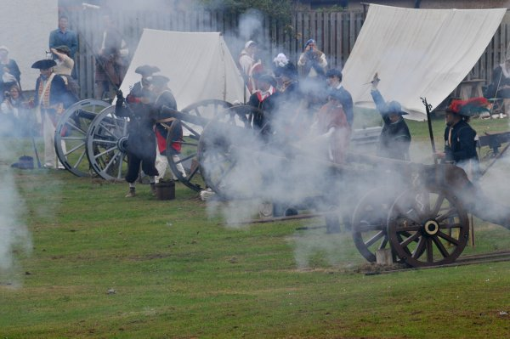
Encore: On a clear day one can see forever

