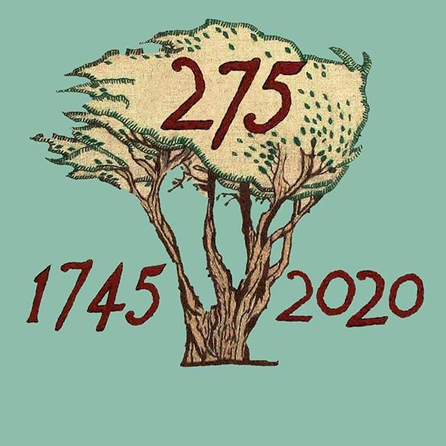

BATTLE OF PRESTONPANS [1745] HERITAGE TRUST
MINUTES OF 113th MEETING OF THE TRUSTEES HELD ELECTRONICALLY FROM MAY 11th/ 18th 2020 BY EMAIL ITERATION & ZOOM

QUORATE throughout/ contributing:
Gordon Prestoungrange of Lochnaw [in the Chair]
Sharon Beck*
Gareth Bryn-Jones
Sylvia Burgess
Herbert Coutts
Sharon Dabell
Arran Johnston*
Joe Goldblatt
John Home-Robertson
Avril Wills of Lochnaw
Julian Wills of Dolphinstoun
Mathew Wills of Prestoungrange
APOLOGIES:
Kenneth Cameron
Brett Fletcher
Pat O’Brien

1. MINUTES of 112/20 Meeting of the Trustees held on March 12th 2020 which had been e-circulated by the Secretary, were proposed on ZOOM May 14th 2020 @ 4.05m and unanimously confirmed as a correct written record.

2. JACOBITE TRAIL

01. That Michael Taylor had identified a small group of those who attended the November 2019 Colloquium and identified suggested next steps which must necessarily await the relaxation of national Covid 19 constraints. The ambition remains to exchange views with those who have collaborated thus far and with The Outlander Trail.
02. Resolved: To continue preparation of the draft proposal for VisitScotland with the nationwide sub-group to submit sine die; Herbert Coutts with Mike Taylor to lead.
03. That the development of the ‘Virtual Jacobite Trail’ as an integral element of the 275th Comprehensive Digital Strategy when deploying ‘Restricted Funds’ should be continued with all those attending at the Colloquium on November 5th 2019 potentially included and more beyond.

3. TASKFORCE 275 REPORTS/ SESSIONAL CONTRACTORS

01. That reports from the iterative email exchanges of the Taskforce remain positive with great credit due to the continuing commitment and enthusiasm of the ‘Sessional Contractor Resourcing’ provided since April 1st by Sharon Beck and Arran Johnston as agreed at the 112th Meeting.
02. Resolved: That Sessional Contractors continue working with the Taskforce to draft a ‘Revised Comprehensive eAsset Building Strategy’ for Project 275 with f2f as emergent and any requisite postponements within the December 31st 2021 horizon.
03. That the ‘Revised Strategy shall [a] specifically enhance the Facebook activity as the only ‘visible’ stimulus from the 275 Project whilst preparations are going along with small deliberately scheduled contributions as well as the Jacobits elements; [b] embrace the 2021 Re-enactment as part of the Project in a creative/ innovative way; [c] ensure no loss of pace on the restructuring of the website; and [d] engage with PR team led by Martha Bryce to get exposure for the decisions the Trust takes.
04. That the Revised Strategy at 3.02 above shall be developed at once by the Sessional Contractors with the Taskforce and tabled for approval by Trustees firstly by written efile and then via ZOOM discourse as business of the 114th Meeting of the Trustees.
05. Resolved: That a public statement be developed by the
Taskforce confirming that a maximum £55/£90K of Restricted
Funds previously allocated as match funding with NLHF and
other donors will continue in place under the Revised Strategy
and publicly identify the rationale for that decision.
06. That the public statement at 3.05 above will be e-circulated and
ZOOMed amongst Trustees as for the Revised Strategy at 3.02 as
business of the 114th Meeting.
07. That revised arrangements for Bòrd na Gàidhlig’s support for
our postponed ‘Cultural Invitation’ to schools and for VisitScotland-
Clans & Historic Figures support of Commemoration on September
19th/ 21st have already been agreed.
08. That unless circumstances change significantly the Trustees will not seek to Pause or Suspend any parts of Project 275 but would explore with NLHF the possibility of an extension beyond December 31st 2021 to make sure the Legacy benefits of the Project are fully captured including the Gaelic dimension.
09. Resolved: That Contractors seek an early resolution of the website redesign including sharing the proposed dendrogram, giving first refusal to Edinburgh College under revised arrangements; and to report to the Trustees at the earliest opportunity.
10. *That Arran Johnston declared his interest in the above decisions
and as a Trustee took no part in the voting thereon although was
invited along with Sharon Beck by the Chairman to contribute to
discussion of all these issues.

4. ‘CONVERSATIONS’ WITH EAST LOTHIAN COUNCIL & HARGREAVES

01. That Monica Patterson, CEO of ELC, had responded noting the battlefield issues raised, confirming ELC’s support for the Trust, and agreeing to a meeting as soon as circumstances permit.
02. Resolved: That Herbert Coutts and John Home-Robertson would lead discussions with ELC’s officers and politicians.
03. That the Partnership Application from July 2020 with ELC to Bòrd na Gàidhlig has been submitted and a reply is awaited.
04. That there is still no news of any future invitation to tender re agriculture on the battlefield for 2020 but the Trust remains committed to reapply.
05. Resolved: That the Trust should contact the CEO to confirm that it supports the proposal to seek NPF4 status and it looks forward to being engaged in its developing plans.

5. LIVING HISTORY CENTRE at BLINDWELLS

01. Resolved: That Gordon Prestoungrange and Sylvia Burgess would make renewed contact with Iain Slater at Hargreaves to elicit the promised 1st Option on lands for the Living History Centre at Blindwells.
02. That Sylvia Burgess would be asked to ensure a meeting is arranged between Iain Slater, Gareth Bryn-Jones and ENA, the Blindwells architects at the earliest opportunity.
03. Resolved: That Restricted Funds would be released to support the preparation of the requisite planning details and visuals to make ready for the Funding Appeal in due course.
04. That contact will be maintained with EventScotland’s Regional Director Neil Christison who met with the Trustees viewing the battlefield and Living History Centre locations from the Battle Bing as plans evolve.

6. PLANNING FOR INTERREGNUM 2022/ 2026

01. That since there would be an inter-regnum after the completion of Project 275 and the opening of the Living History Centre, during which the Appeal would be proceeding, a plan should be developed for which appropriate support will be required.
02. Resolution: That Arran Johnston and Gordon Prestoungrange should take the lead in formulating a Draft of such a Plan.

7. FRIENDS OF THE PRINCE BENEFITS

01. Noted the comprehensive suggestions tabled by Joe Goldblatt as received from Pam Judson and thanked them both.
02. Resolved: That the Contractors work with Joe Goldblatt to enhance the current benefits of Friends of The Prince on the website; seek to increase enrollments there; but not to contemplate any subscription until such time as options available made it more worthwhile.

8. DATES OF FORTHCOMING MEETINGS & EVENTS

01. That the 114/20 Meeting of the Trustees will take place on Thursday June 11th 2020 using the same format as for this 113th Meeting; or earlier on the call of the chair.
02. That the 115/20 Meeting of the Trustees will take place on Thursday 16th July 2020 under whatsoever arrangements shall be deemed appropriate at that time.
03. That the Contractors have been asked to establish a regular opportunity via ZOOM to keep Trustees up to date on their activities as well as alerting all to the patterns of Facebook activity.

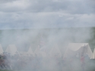
Encore: On a clear day one can see forever

