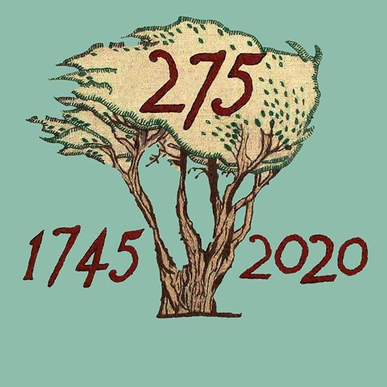

BATTLE OF PRESTONPANS [1745] HERITAGE TRUST
MINUTES OF 111th MEETING OF THE TRUSTEES HELD ON FEBRUARY 20th 2020 IN THE JAMES PARK BISTRO AT THE PRESTOUNGRANGE
GOTHENBURG, PRESTONPANS EH32 9BE

CONTRIBUTING:
Herbert Coutts [in the Chair]
Sharon Beck
Gareth Bryn-Jones
Sylvia Burgess [e]
Arran Johnston
Gordon Prestoungrange of Lochnaw
Avril Wills of Lochnaw
Julian Wills of Dolphinstoun [e]
APOLOGIES:
John Curtis
Sharon Dabell
Brett Fletcher
Joe Goldblatt
Pauline Jaffray
Pat O’Brien
Mathew Wills of Prestoungrange

1. MINUTES of 110/20 Meeting of the Trustees held on January 16th 2020, which had been circulated by the Secretary, were proposed/ seconded by Sharon Beck/ Herbert Coutts respectively and confirmed as a correct written record.

2. JACOBITE TRAIL

01. That Michael Taylor was following up with a small group of those who attended the November 2019 Colloquium and preparing a Draft outline for discussions with VisitScotland. The ambition is to meet those who have collaborated there with The Outlander Trail.
02. Agreed to explore whether a Jacobite Festival Weekend /follow up Colloquium [as well as the already arranged Helion Books Conference] might be included in the 275th Anniversary programme during 2020/2021 not least if The Jacobite Story becomes a salient theme for the planned Living History Centre.

3. WWW.PATHTOVICTORY1745.ORG + TASKFORCE 275 REPORTS

01. That the application to Bòrd na Gàidhlig had been successful in the sum of £3,000, giving most welcome recognition and enabling bilingual signages especially for the 10/17 year old invitations to create new poetry/ prose/ visuals of the battle story and updating our [2009 Homecoming] Clan Display boards.
02. That the report from the 2nd Meeting of the Taskforce remains euphonic with great credit due to the commitment and enthusiasm of the temporary Sessional Resourcing provided to March 31st by Sharon Beck and Arran Johnston.
03. That details of the 10/17 year old’s Invitation are ready for release at month end in English/ Gaelic and that co-operation of ELC has been assured.
04. Details of the Inverurie exhibition opening April 1st with its several associated elements are now virtually complete as is the Helion Jacobites in the 1745 Conference for September 19th.
05. Potential suppliers of project management in 2020/ 2021 have
been given authorization to submit group/ corporate proposals by
March 6th given the challenges of dedicated employees throughout the
sequence.
06. Applicants for interviews will be invited on March 12th to meet
Trustees with a decision made to enable contracted services to replace
the present temporary provisions from April 1st 2020.

4. ‘CONVERSATIONS’ WITH EAST LOTHIAN COUNCIL

01. That no details of the Master Plan for Prestongrange Heritage Park promised in September 2019 have been received but requested support for contra rental against ELC’s battlefield sprouts revenue has been rejected.
02. In the immediate future ELC’s educationalists are working with the 275 Project to engage 10/17 year olds; the exhibition at the John Gray Exhibition will use of Gaelic for interpretation and ‘pop ups’; there is possible joint development of Gaelic lessons for adults as partners with support from Bòrd na Gàidhlig; support has been promised for ongoing maintenance of the Battle Bing; and the Trust makes occasional use of Council facilities such as the Town Hall.
03. That there is still no news of any future invitation to tender re agriculture on the battlefield for 2020 but the Trust remains committed to reapply.
04. That following circulation at Cockenzie & Port Seton CC of a misleading leaflet on the future of ‘all’ the Cockenzie Power Station lands a request has been submitted in extremis to challenge ELC’s putative suzerainty at a meeting with ELC’s CEO, Monica Patterson.
05. Agreed that discussions with ELC’s political leaders should also be reactivated including suggestions that the Trust should acquire or long lease the battlefield.

5. OUR LIVING HISTORY CENTRE at NW BLINDWELLS

01. That the site meeting with Iain Slater of Hargreaves at Blindwells on January 30th had gone well and agreed next steps to ensure the location debated. Hargreaves agreed [i] to draft a First Refusal Agreement on the NW corner site there; and [ii] to give the Trust’s architect Gareth Bryn-Jones access to their own Town Centre team so that visuals can be speedily created.
02. That he follow up meeting with Iain Slater has been confirmed for Edinburgh on March 12th.
03. That contact will be maintained with EventScotland’s Regional Director Neil Christison who met with the Trustees viewing the battlefield and Living History Centre locations from the Battle Bing as plans evolve.
04. That it is now the overarching goal of the Trust to create such a Centre telling The Jacobite Story – and the especial role of the Battle of Prestonpans in September 1745

6. PARTNERSHIP WITH EDINBURGH COLLEGE

01. That the third partnership meeting had been held by Arran Johnston with IT students and Faculty at Edinburgh College where good progress is being made on the nascent website’s dendrogramatic wire frames and timescaling; this initiative also encompasses the social media. The sole exclusion is @ www.scottishdiasporatapestry.org for which alternative host provision will be necessary by summer 2020.
02. Discussions have also been held with the Gaelic languages unit exploring possibilities for collaboration with them; and with Faculty in the Built Environment.
03. Website designs for the fund raising Appeal will also be developed as a priority.

7. TAPESTRY EXHIBITIONS/ SCHOOL VISITS/ MOUNT
FELIX/ US 05/ AOB

01. That the Diaspora Tapestry is contracted and scheduled for Dundee’s Verdant Works June 13th - September 12th 2020 .
02. That several Prestonpans Interpretation BattleBoards require
restoration and that plans for this are proceeding initially with the
board opposite the Memorial Tables on the Waggonway including Gaelic
translations.
03. That School visits and occasional lectures and tour groups
continue with 60+ primary school children from Dunfermline before month end, with plans in 2020 to train and induct further Guides.
04. Confirmed that the Mount Felix Tapestry had been collected from Walton-on-Thames on January 28th for exhibition February 26th/ March 11th at the Gothenburg including the opportunity to display the Scottish Diaspora’s New Zealand panels.
O5. There had been an excellent response from the New Zealand Association in Scotland and the NZ Consul General in Edinburgh, Sir Neil MacIntosh; March 3rd Lunchtime is being promoted as a focus time for the Association on Facebook and Friends of the Tapestries will also be formally invited; regrettably Andrew Crummy, its panels’ designer, has declined to attend.
06. That US05 panel has now been returned to Scotland for
completion here under the leadership of Sharon Beck.
07. All revised copy is now with John Unwin for the 3rd Edition of the Official Guide to the Scottish Diaspora Tapestry save the final image of US05; printing will begin once remaining stocks are sold most likely at Dundee.
08. The formal Regimental Dinner of the Lothians and Borders Yeomanry at the Prestoungrange Gothenburg is to be held on May 16th 2020 – commemorating the role of Capt. Thomas Nelson III
09. That an invitation of cooption to the Trustees has been made to John Home-Robertson, former MP/ MSP for East Lothian and he will again be attending the meeting on March 12th.
10. That an invitation has also been extended to former Founding Trustee, Peter MacKenzie, to rejoin the Trustees and his decision is awaited. He would inter alia be able to offer unique contribution through his skills with Gaelic.

8. DATES OF FORTHCOMING MEETINGS & EVENTS

01. That the third meeting of Taskforce 275 will take place in Prestonpans on March 11/12th 2020 including short listing of sessional resource providers to deliver all aspects of the programme.
02. The 112/20 Meeting of the Trustees will take place on Thursday 12th March 2020 from 6pm at The Prestoungrange Gothenburg.
03. That the Mount Felix Tapestry will be exhibited in the Thomas Nelson Suite from February 26th / Wednesday March 11th 2020. Friends of the Tapestries will be invited to a Viewing Night and selected NZ Diaspora panels will also be displayed. NZ Association in Scotland is convening a lunchtime gathering on March 3rd.
04. That the 113/20 Meeting of the Trustees will take place on Thursday 14th May 2020 from 6pm at the Prestoungrange Gothenburg.
05. The Inverurie Exhibition of the Prestonpans Tapestry will open on April 1st 2020
06. The Helion Books Conference on The Jacobites in the 1745 Rising will take place on September 19th 2020 in the Thomas Nelson Suite at the Prestoungrange Gothenburg from 10am/ 5pm.

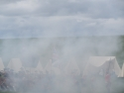
On a clear day one can see forever

