PETITION TO EAST LOTHIAN COUNCIL

Name of Principal Petitioner (and organisation if applicable) | DR GORDON PRESTOUNGRANGE MBE - for Trustees of  BATTLE OF PRESTONPANS [1745] HERITAGE TRUST  Scottish Charity SC 037447  www.battleofprestonpans1745.org
Address of Principal Petitioner | 227 HIGH STREET, PRESTONPANS EH32 9BE  prestoungrange@aol.com
Contact telephone number of Principal Petitioner | 01875 819922  0792 852 6629
Title of Petition | ESTABLISHING THE LIVING HISTORY CENTRE [LHC] IN  2023 TO COMMEMORATE THE BATTLE OF PRESTONPANS  1745 – www.visionforvictory1745.org
Petition text. We the undersigned respectfully call upon East Lothian Council to .... | - Reaffirm and express enthusiastic support for the creation of a world-class Living History Centre in East Lothian to commemorate and interpret the Battle of Prestonpans 1745 in the context of Scotland’s Jacobite Heritage and to provide a permanent home for the Prestonpans and Scottish Diaspora Tapestries.  - Afford full assistance to the Battle of Prestonpans (1745) Heritage Trust as it moves forward along the Path to establish a financially self-sustaining Living History Centre by 2023, which will provide on-going heritage, cultural and educational benefits to the people of East Lothian, and will attract visitors from across the nation, the rest of the UK and internationally.  - Assist the Trust along the Path by the provision of warehouse accommodation for and insurance of the tapestries and accumulated heritage assets  - Support the Trust by all possible means to raise the capital funding for the Living History Centre, including an endowment, the income from which will be used, as appropriate, to supplement admission charges and invest in future improvements and development.  - Assist the Trust to ensure that people of all ages and the widest backgrounds are given the opportunity to learn about, and contribute to the study of, the Battle of Prestonpans, and all aspects of the Jacobite story.  - Work with the Trust to protect conserve and interpret the site of the Battle of Prestonpans as defined in the Scottish Government’s National Inventory of Battlefields in all appropriate ways, to ensure that no undue archaeological disturbance occurs including the remains of the battle’s war dead buried on the battlefield and to maintain all extant battlefield interpretation and memorials.  - Identify an Elected Member to serve on the Trust’s board, and a Council officer to liaise between the Trust and all appropriate Council service areas as the Living History Centre project is taken forward along the Path to completion by 2023.
What action have you taken and who have you contacted before submitting this petition and what was the result of this? | The Trust has petitioned both ELC [21.01.2010] and the Scottish  Parliament [PE1387] over the past decade and received  comprehensive support therefrom and from HES, NTS and the then  Cabinet Secretary for Culture and all successors, and Iain Gray MSP.  At the behest of ELC we applied unsuccessfully for HLF support for  the LHC to be located at Prestongrange Museum in the BathHouse.  We have subsequently taken on board the observations of HLF and in  discussion with The Provost and Economic Development we have  identified several locations close to the battlefield.  The Trust, with support from HLF Resilience Funding, has conducted  an External Audit and a Comparative Study of other Battlefields  alongside RGA Economic Feasibility Studies. These are the basis,  after widespread consultations, for the formal Prospectus at  www.visionforvictory1745.org for the LHC which all believe can be  self sustaining once capital funding has been invested with visitor  potential in excess of 80,000 pa + school visits. We have been  informed that the petitioned support called for above is a  prerequisite for further consideration by The National Lottery  Heritage Fund as well as being inescapably appropriate.  We have held discussions with CEO of VisitScotland which is now  ready to support the Trust in its physical and activity programme  designs to maximise effectiveness with visitors.
Please provide more information about your petition | Our Petition to ELC in 2010 included aspects of battlefield protection  and interpretation which we have followed through mainly on  our own account. As a charity we took full financial responsibility for  the HLF Application re the BathHouse at Prestongrange Museum. We  have taken a lease on the Gardiner Obelisk, the Bankton Doocot and  the Battle Bing and with Viridor support upgraded and maintained  them.  We have crafted two new Commemorative Tables for the Highland  Clans and Hanoverian Regiments on the 1722 Waggonway. With  support from Bord na Gaidhlig we have placed directional path and  street signs to the battlefield itself and re-enactments have been  regularly conducted with ELC and EventScotland support. With HLF  support we have installed Interpretation Boards across the battlefield.  We have created the103 metre Battle of Prestonpans Tapestry which  has toured with approaching 500,000 visitors and the 155 metre  Scottish Diaspora Tapestry with in excess of 250,000 including a  global tour. The LHC will provide permanent homes for both these  unique artworks.  The full extent of our activities since 2006, including our  schools/educational programme, which will in the future be  professionally led and housed in the LHC, are identified in the HLF  sponsored External Audit attached.
Signature of Principal Petitioner | 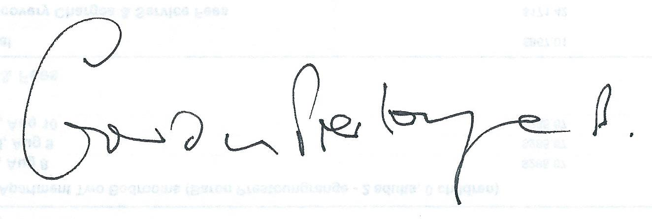

Your details will only be held by East Lothian Council and will not be used for any purposes other than in relation to this petition.

For Office Use:
Date Received:
Receiving Officer:
Petition Reference:

