PETITION TO EAST LOTHIAN COUNCIL

Name of Principal Petitioner (and organisation if applicable) | DR GORDON PRESTOUNGRANGE MBE  BATTLE OF PRESTONPANS [1745] HERITAGE TRUST  www.battleofprestonpans1745.org
Address of Principal Petitioner | 227 HIGH STREET, PRESTONPANS EH32 9BE  prestoungrange@aol.com
Contact telephone number of Principal Petitioner | 01875 819922  0792 852 6629
Title of Petition | 1745 BATTLE HERITAGE COMMEMORATION &  INTERPRETATION AT BLINDWELLS ‘NEW’ COMMUNITY
Petition text. We the undersigned call on East Lothian Council to.. | WE THE TRUSTEES of the Battle of Prestonpans [1745] Heritage  Trust , after extended discussions with Hargreaves, call on East Lothian Council to take and/ or support all appropriate steps to ensure enduring respect for the 1745 Battle Heritage at the former opencast coal mine known currently as Blindwells, including but not exclusively the following:  [i] to name the ‘new’ community Charlestoun in honour of Prince  Charles Edward;  [ii] to ensure that a south/ north route is named The Riggonhead  Defile to commemorate the path taken through the marshy ground at  dawn on September 21st 1745 by the Highlanders on the advice of local farmer John Anderson’s son Robert.  [iii] to place Interpretation Boards along the Defile thus named;  [iv] to name neighbourhood roads in commemoration of Robert  Anderson, the Clans and Hanoverian Regiments that fought that day,  together with other cultural legacy names e.g Adam Skirving, Alasdair  Mac Mhaighstir Alasdair, Philip Doddridge;  [v] to deploy % For The Arts from developers for the creation and  erection of Scotland’s first equestrian sculpture of The Prince at/  close by The Prince’s Loch and Prince’s Park already designated by  Hargreaves;  [vi] to use the Gaelic alongside English in all designations to reflect  and advance awareness of the language used by the great majority of  Highlanders at the battle;
What action have you taken and who have you contacted before submitting this petition and what was the result of this? | From 2006/ 2010 we lobbied and collaborated with then County  Archeologist Biddy Simpson when initial plans for the area were  discussed. Her Report is attached.  Since 2017 we have held continuing discussions with East Lothian  Council and Hargreaves to identify and evaluate suitable locations for our Living History Centre in close proximity to the battlefield e.g. SE of the Battle Bing or at the NW corner of ‘Charlestoun’.
Please provide more information about your petition | - The ‘new’ community falls within the nationally Designated  Battlefield of Prestonpans [BTL16]September 1745 as recorded in the National Inventory by Historic Environment Scotland. All planning requires comment from HES to whom this Petition has been forwarded.  - The tactic of taking The Riggonhead Defile, shown to The  Highlanders by Robert Anderson, through the marshy ground overnight to be enable the Charge at dawn was a crucial element in the swift victory that the Highlanders achieved.  - Each year when providing re-enactments since 2006 the Trust  has commenced the Weekend’s commemoration with a Dawn  Walking of the Riggonhead Defile and struck a Medal for those who  so participate.  - The Trust collection of paintings by the late Andrew  Hillhouse includes a widely acclaimed work depicting the Dawn Walk  – as does Outlander in its tv and literary works.  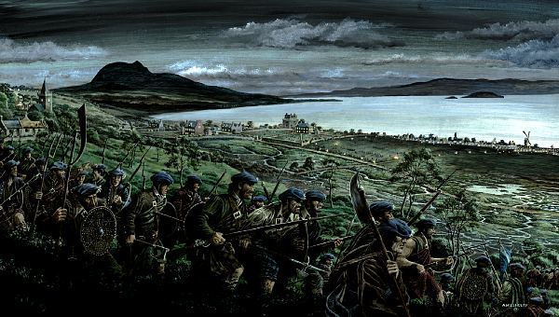  - The Trust believes that by ensuring the commemoration and  interpretation of the 1745 battle heritage of the ‘new’ community of  Charlestoun it will greatly assist its social cohesion by giving and  honouring a significant ‘sense of place’ for incoming residents that  connects strongly to the existing communities in Prestonpans/  Cockenzie & Port Seton/ Longniddry.  - The Trust will also do all it can to assist the preservation and  interpretation of the additional aspects of community heritage  identified earlier by the County Archaeologist.  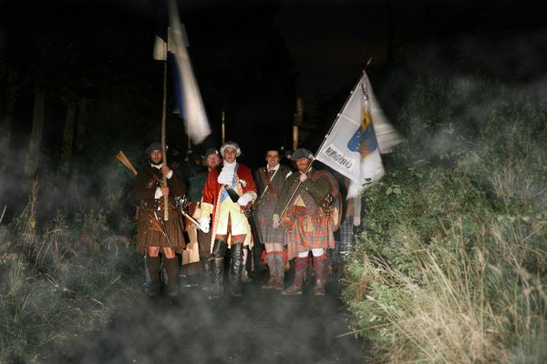
Signature of Principal Petitioner | 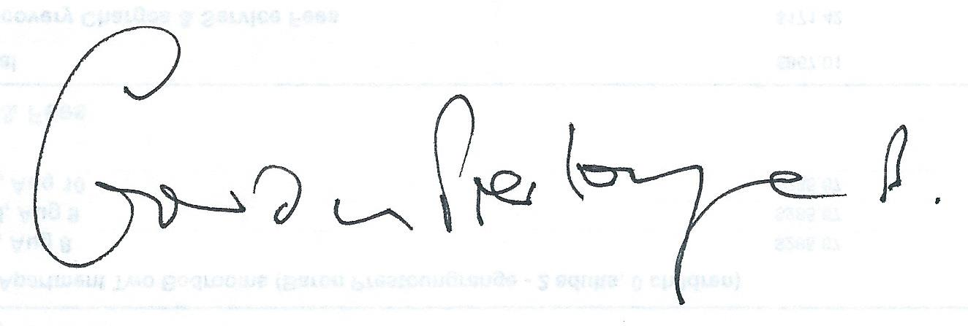

Your details will only be held by East Lothian Council and will not be used for any purposes other than in relation to this petition.

For Office Use:
Date Received:
Receiving Officer:
Petition Reference:

Signature | Print Name (Block Caps) | Contact Address

