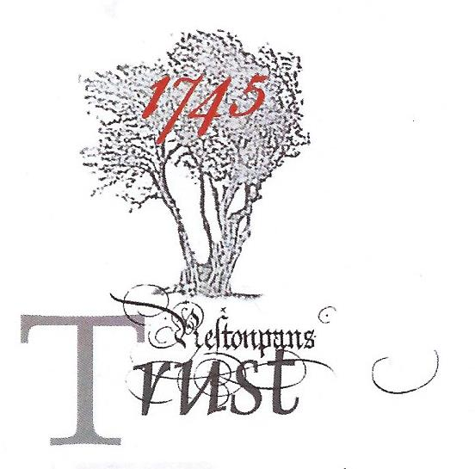
June 8th 2019 v3
CONSULTATIONS LEADING TO OUR ‘AGREED’
Path to Victory & Vision for Victory 1745

Introduction: The Draft Manifesto for the Optimal Way Forward for the Trust was crafted by the Trustees in the light of their accumulated experience since 2006, the comments received from the External Audit processes and the Comparative Studies of other battlesites internationally. The Consultation on the Draft was announced to and shared across the media in March 2019 with recorded combined reach of 5,214,586. It took the Draft back to the original participants in the External Audit, to Community Councils, to an Open Consultation in Prestonpans Town Hall and to online respondents through Survey Monkey. The outcomes of those Consultations at end May have been incorporated in the final ‘agreed’ manifesto under the title VisionforVictory1745. The Trust proposes to achieve that Victory by following its now delineated Path to Victory 2019-2023.

Significant Conclusions: The most significant conclusion was that ‘everyone’ thought a Living History Centre for the Battle of Prestonpans was a commendable and worthwhile ambition and almost all vowed they would visit when it opened.

- Interest in the Jacobite Cause at large was felt to be substantial and compelling internationally and nationally as the context for the Centre as was focussed interest in ‘Bonnie’ Prince Charles Edward
- That the Trust’s longstanding emphasis on Hope/ Ambition/ Victory characterised in the inspirational youthful leadership of The Prince should be a cornerstone of the interpretation
- The best location for the Centre would be close to the already interpreted battlefield and readily accessible from the A1
- The exceptional cultural heritage arising from the battle should certainly be exemplified as well as the vitally necessary immersive interpretation of the battle itself
- The battle should be interpreted from both sides – Victors and Losers/ Jacobites and Hanoverians – and from the perspective of the local community on which it impacted in 1745 with their differing loyalties
- That full-scale September re-enactments [media reach 2018 was 14.5 million/ attendance 2500] should take place on a regular cycle allied with extensive use of cameo moments as presented since 2007
- Whilst the Centre will be the reference point for most visitors the synergetic relationship with the already interpreted battlefield, its monuments, Tranent churchyard and Bankton Doocot must be integral to the interpretation provided
- That the absolute protection of all the Designated Battlefield and the future patterns of agriculture thereon must be congruent with the battlefield interpretation and include the significance of the iconic thorn tree
- That the interpretation and commemoration of the Riggonhead Defile from Tranent to Seton Collegiate must be honoured in the new emerging community at Blindwells/ Charlestoun
- That careful attention should be given to trends in international and national tourism with requisite flexibility to respond built into the design
- That whilst self-sustaining financial operations were a realistic expectation it would require skilled highly professional leadership and management for launch and operations
- That although Prestonpans is not currently as ‘well known’ as Culloden or Bannockburn the opening of a world class centre would certainly increase awareness as would placing the battle in the Jacobite context and honouring ‘Bonnie’ Prince Charles Edward
- The school and adult educational opportunities were numerous and should be further ambitiously developed
- That the Trust’s extant pioneering yet tentative role as champion of the Gaelic language as spoken by the Highlanders in 1745 should be deliberately advanced through interpretation and cultural dimensions including poetry and song
- That national and county institutional support should be ensured as well as the enthusiastic commitment of the local community
- The quality of the main exhibition must be world class to ensure maximum impact and word-of-mouth recommendations from the outset and drive individual repeat visits
- Repeat visits from nearby residents would be determined by the scope of the occasional exhibitions/ activities/ programmes provided and the effectiveness and character of ongoing social media
- Catering and shop facilities must be exceptionally presented and led as they are most significant contributors to the economic sustainability of the Centre
- That opportunities for community/ shared use of the Centre’s facilities should be maximised wheresoever it might be located so that a strong sense of community ownership and engagement should prevail with active community representation as appropriate

