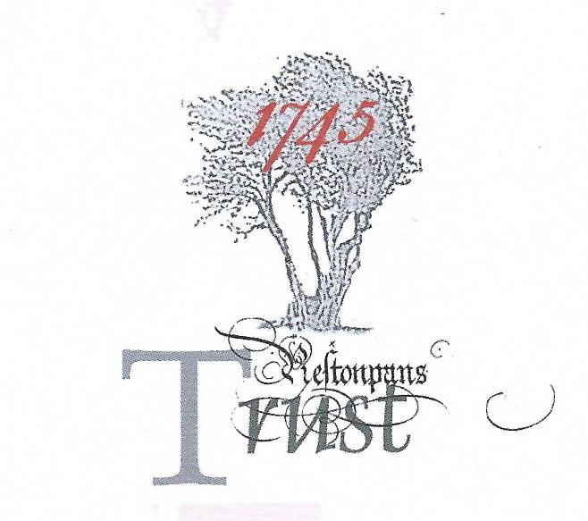

MINUTES OF HLF RESILIENCE PROJECT TASKFORCE
held April 10th/11th/12th 2019 @ The Prestoungrange Gothenburg, Prestonpans, EH32 9BE
*Part time contributions [e] electronic contributions

Present: Gordon Prestoungrange [in the chair]
Sharon Beck
*Martha Bryce – Soundbite PR
*Stephen Connolly – DC Consulting
Herbert Coutts
Sharon Dabell [e]
*Rachel Mackie
Arran Johnston
*Sharon Saunders
*Susan Smith
Michael Taylor [e]
Mathew Wills [e]

Received: Report from Scottish Conservation Centre on Scottish Diaspora Tapestry. Draft Proposals re [a] Vision for Victory; [b] Path to Victory; [c] Invitation to Comment - to arrive at Agreed Manifesto. Discussion Papers: Draft 5 year trading forecast; Draft MoU with Hargreaves re Charlestoun; Next Steps re Jacobite Trail/ Assets; Draft HLF Project Evaluation Report; correspondence with ELC re FoI Request on sprout farming on battlefield & identification of Living Hi
story Centre sites; with Tom Ingrey-Counter at HLF re Next Steps.

Noted: That Hargreaves’ MoU response was awaited; that Final versions of the External Audit and Comparative Study will be tabled at the next meeting; that Concept Visuals on the Centre are awaited from Gareth Bryn-Jones.
Reviewed & Discussed: The content of all new papers tabled and those carried forward from our March 20th/ 21st 2019 Meeting. Concluded:

- That the Draft Manifesto, named Vision for Victory, together with Draft 3 year Transition Phase, named The Path to Victory, should be published by Dr Arran Johnston at a new dedicated website on Thursday April 18th and announced in East Lothian Courier.
- That the two above documents should be accompanied by our Invitation to Comment online on the gestalt offered but also via a questionnaire on selected themes e.g. the scope of contextualisation of the focussed exhibition.
- That the website would be intent on capturing from those who comment their email addresses and areas of interest as well as any willingness to volunteer to assist – all to initiate the creation of the dBase of Friends of the Prince as envisaged on the Path to Victory.
- That East Lothian Council’s offer to assist in securing feedback from the consultation process should be accepted and details shared with them as soon before public release as may be possible.
- That face to face meetings should be held with the Community Councils in Prestonpans, Port Seton/ Cockenzie and Longniddry as soon as possible and a ‘Public Open Consultation’ be convened in Prestonpans Town Hall.
- That Dr Stephen Connolly would immediately take the Invitation to Comment back to those he consulted when undertaking his External Audit and table the commentary there arising before May 9th 2019. On this date all online comments received will also be evaluated for inclusion in the final Agreed Manifesto for tabling in the Project Completion/ Evaluation Report with HLF.
- That Martha Bryce shall continue her PR initiatives to maximise awareness of and responses to the Vision for Victory.
- That Michael Taylor shall continue his initiatives in pursuit of establishing The Jacobite Trail hubbed from the Living History Centre and embracing therein a Jacobite Asset Register, all to be publicly debated at a Jacobite Colloquium in the final quarter of 2019.
- That Mathew Wills should continue his draft budget analyses exploring various assumptions as insights are gained from NTS and others.
- That Dr Arran Johnston should begin preparing draft programmes of activities at the Centre across its first two years trading.
- That Dr Gordon Prestoungrange should continue to explore the future design for the integrated online presence of the Trust and The Prince’s Friends, both archival and making extensive use of social media.
- A Project Enquiry will necessarily be submitted to National Lottery Heritage Fund for up to £250,000 towards the implementation of The Path to Victory, to be formally submitted as an Application no later than August 20th 2019; and that other funders will also be sought for selected elements on The Path as well as the commitment of the totality of the £100,000 Restricted Funds held in trust.

Debated the options for the Centre being located in close proximity to the battlesite:

Met with the Heads of Communities and Economic Development and colleagues to review the notification that neither St Joseph’s or the former Power Station lands were presently available as a location. Agreed that ELC would enquire whether the recently browned-field site to the east of the Battle Bing was potentially available.

Discussed the emergent Vision and Master Plan ELC has for Prestongrange Heritage Museum and ELC’s request that the Trust include in its consideration for location a return there within the emergent framework. Agreed that the Trust would be willing to meet with the consultants employed by ELC for Prestongrange to see what might be complementary and ELC agreed so to arrange in due course. Accepted that whilst evaluating all feasible options in the end wherever the Trust selected it would wish to have ELC’s endorsement and support therefor.

Discussed the extent of discussions thus far with Hargreaves at Charlestoun which ELC considered to be a realistic option for the Trust to pursue.

Concluded that as on April 12th there were three live options – Charlestoun, Bing East and Prestongrange Museum. The Invitation to Comment would be specifically asked whether proximity to the battle site was unavoidably significant or whether alternative locations further afield might be considered.

