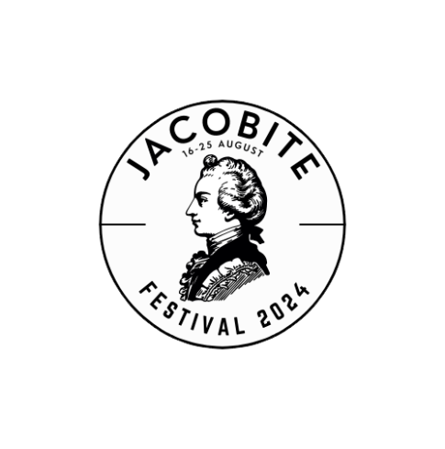

**A report on the first Jacobite Festival Aug 16-26, 2024**

1. **Background**

The constituents of the Jacobite ‘community’ in Scotland were drawn together by two very successful colloquia promoted by BPHT in 2019 and 2022. This initiative led to the creation of the Jacobite Trail online site, looked to share information and promote collaborative working among the custodians of Jacobite heritage. The concept of a Jacobite Festival emerged in 2023 (when it was titled ‘Jacobite Week’) and was conceived as an effective promotional tool that would involve participant organisations during a week centred on the anniversary of the raising of the Standard at Glenfinnan on 19 August 1745. This Scotland-wide initiative would involve the collective marketing of whatever type of Jacobite-themed initiative felt appropriate to each organisation. This might be an exhibition, a single object display, a walk, a talk or an event of any kind around the 17-25 August 2024. It did not require a new event and could simply involve the highlighting of an existing initiative that could be collated into the national publicity campaign.

This concept was circulated to the Jacobite Trail mailing list in November 2023 and responses were very positive. By February 2024 some 12 organisations had definite proposals and although some of these did not materialise the final event had 15 organisations delivering 23 events from the Great Glen to the Borders.

1. **Organisation**

General promotion of the Jacobite Festival to participant organisations and the collation of their events was carried out by the author. A Festival page on the Jacobite Trail website was created by Arran Johnston and promotion via social media was contracted to Sound Bite PR. Sadly, an application to NLHF for financial support was unsuccessful and the programme of social media promotion was supported by a financial donation and scaled accordingly. Sound Bite was supplied with a list of events and in the run up to the Festival posted advertisements and three posts per week on Facebook/Instagram. Sound Bite’s report is appended to this report. In summary the social media campaign reached 102,000 individuals, two thirds of whom came via the paid advertisements. Over 3,000 people visited the pages and 2,400 interacted in some way via ‘likes’, ‘tags’, ‘follows’, ‘comments’ etc. All were overwhelmingly via Facebook and increased the users of the Jacobite content massively. Unfortunately it has not been possible to compare the before and after-Festival data for the use of the main Jacobite Scotland web page. This issue has been resolved but it seems that historical data from earlier this year is not accessible.

1. **Events Data**

Most of the organisations involved returned some information on the events that they organised. This data varies widely in scope and content and it seems that many organisations do not (or did not in this instance) collect data on their users that is tied to particular initiatives.

Data from individual sites (summarised):

Urquhart Castle (Historic Scotland) – re-enactors on site for one week. Total attendance 23,703. This remarkable figure shows the importance of the site and Loch Ness in the tourist itinerary and is atypical of any other participant organisation. There is no other data on users such as age profile. The organisers have their own well organised promotions but were aware of the social media promotion of the Festival. They would take part again.

Dunkeld Chapter House Museum – re-enactor led tours. Local P5/6 class in the morning and four open tours. 30 participants in the latter(adults and children), positive feedback. Brought extra visitors to the museum. Self-promoted but aware of the social media promotion. Would take part again.

West Highland Museum - four events: two childrens events, a stall at the Glenfinnan Games, ‘Jacobite Night’ at the museum. No figures. Positive feedback. Self-promoted but used and shared the social media posts. Local media and word of mouth important but some visitors had seen the Facebook posts. Would ‘definitely consider’ doing again.

Falkirk Battlefield Trust – Guided battlefield walk. 12 people aged 30-70. Most saw it on the Battlefield’s own Facebook page. Organiser aware of social media promotion. Would do it again.

Fingask Castle – access to house (normal closed) garden and tea. 15 adults age 24-60. Some visitors aware of the Festival. Self-promoted. Did not see social media.. There was a clash with a Borders event which may have attracted possible attendees. ‘Possibly’ do it again.

BPHT – 3 events, total 58 participants, 5% under 15 years of age, 10% 25-40. Positive feedback at all events. Positive comments about Festival offer . One comment about clashes with Edin Festival. Brought new visitors to the museum and on two days when the museum would normally be closed. Most visitors aware of Jacobite Festival – some had attended other events. Visitors heard via social media and own flyers. Appreciative of social media campaign. Would do it again.

Scottish Battlefield Trust – online event, 25 adults including new contacts. Positive response. Heard of event through social media of the members e-newsletter. Would do it again with an additional event!

Highland Archive Centre – (1) online talk 58 attended. Very positive feedback. Some came to later event. Some came as direct result of Festival. Organisers appreciated the social media promotion. Delighted to do it again.

(2) Jacobite documents pop-up exhibition. 17 adults aged 30-75. Very positive feedback. Some there directly because of festival marketing. Appreciated the social media promotion. Would love to take part again.

Palace of Holyroodhouse – two events: Jacobite short talks in the gallery, about 40 – some of whom had come after seeing the festival programme online; 25 attended the Portrait of the Prince event. “The whole programme and number of venues was fantastic and we were delighted to be a part of it.”

Black Watch Museum – whole day event with re-enactors on site. Sold 52 individual tickets and 5 family tickets. General feedback excellent. No discernible increase in visitors but shop sales up on the day. Promotion through own social media channels, website and with posters and leaflets in the building. Would consider participation again.

Perth Museum – two Jacobite-themed city walks. 40 participants, all adults. Feedback ‘positive overall’. Used own publicity but was aware of the social media. Next year’s schedule already drawn up but will look for opportunity to participate.

Scone Place – two events: Jacobite tour with Ld Stormont (14 out of 24 places taken – all adult); Jacobite day 764 visitors incl. families (an increase for the day). Feedback on both v positive from visitors and the events team. Visitors were aware of the JF. Scone P not aware of social media campaign, they used their own social media and website for publicity. Would take part again.

1. **Observations**

* Feedback about the festival content was overwhelmingly positive
* Our participating organisations do not consistently record visitor data
* Feedback about the utility of the social media campaign was positive
* Public feedback about individual events was very positive
* Some organisations reported a modest increase in visitor numbers, Most did not / could not
* It is not possible to give a total for attendance across Festival events
* Institutions with their own PR / Media staff seem less likely to report details
* Social media proved to be a cost effective promotional tool
* There is no evidence of mutual promotion of events
* The campaign did not include flagship sites (eg NMS, Culloden) which would have been open during the Festival period but which had no special events
* Much time was invested by participant organisations
* Resources invested in the festival itself were modest for the return achieved
* All respondents would take part again (with some caveats about resources)

1. **Next**

* Appropriate feedback to partner and non-partner organisations – report, zoom, colloquium?
* Confirm dates for 2025 Jacobite Festival
* Seek sign-up to participation
* Seek resources
* Programme management - define who is doing what, when
* Define publicity campaign well in advance and broaden to include non-participant organisations
* Consider benefit of a printable festival programme to allow sites to print their own as required (and encourage cross-marketing)
* Maintain profile and momentum



