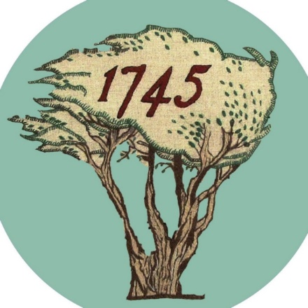

NPF 4 Scotland _ Consultation to March 31st 2022
Observations from Battle of Prestonpans [1745] Heritage Trust
- The Trust was established in 2006 to protect, conserve and interpret the battlefield at Prestonpans, September 21st1745, as now Designated by HES. Throughout our existence we have on no occasion been consulted by any of several intending developers, by East Lothian Council [now direct owners of two thirds of the undeveloped battlefield] or by HES. We have therefore been unable to make constructive input to any of the proposals only to appear in opposition. This process will be far more effective if formally constituted charitable battlefield organisations nationwide such as ours were made Statutory Consultees.
- The Direction re Historic Battlefields given by Scottish Ministers from 1st March 2019 under Regulation 31 of the Town & Country Planning Regulations 2013 requires a Notice of which Battlefield and a Description of the Development. This has meant that the onus falls on HES or local community groups to draw attention to adverse impacts of the historic battlefield. This process will be far more effective if the duty also lies upon the applicant to provide details of the battlefield potentially affected, how all feasible alternatives have been considered and how if the application is successful it should contain a Condition that the history enshrined in the battlefield will be demonstrably more effectively interpreted as an integral element of the application including through appropriate archaeological investigation.
- The National Inventory of Designated Battlefields compiled and maintained by HES under Section 32B of the Ancient Monuments and Archaeological Act 1979 is highly regarded. It affords a strong foundation within the National Planning Framework for the future nationwide identification, formal designation and maintenance of all memorials by host local authorities; and for the onsite interpretation of the history enshrined in each Designated Battlefield. We would wish to see these developments occur nationwide.
- Our experience since 2006 when we have addressed the issues identified at 3 above with positive support from East Lothian Council, NLHF and HES is that not only is the understanding of the nation’s history enhanced but the battlefield becomes a well appreciated benefactor in our environment, a green lung in the community which enhances the health and wellbeing of our residents. The realisation of this double benefit should always have high attention in the consideration of all planning applications for Historic Battlefields.

